**User Guide for SmartSearch: Research Tool**

**Cover Page**

* **Title:** SmartSearch: Research Tool User Guide
* **Subtitle:** Comprehensive Guide to Using SmartSearch for Efficient Research
* **Version Number:** Version 1.0
* **Author/Owner:** Swathi Chidurala
* **Date of Release:** [Not sure what date to mention (Need to discuss with the instructor)]

**Title Page and Copyright**

**SmartSearch: Research Tool User Guide**  
Copyright © 2024 by Swathi97. All rights reserved. Unauthorized duplication or distribution is prohibited.

**Preface**

Welcome to the User Guide for SmartSearch. This document provides detailed instructions on how to effectively use the SmartSearch tool to query, process, and retrieve insights from article URLs. It is designed for both technical and non-technical users.

**Acknowledgments**

I would like to express my gratitude to the following platforms and technologies that made this project possible:

* **Hugging Face**: For providing a robust and user-friendly platform to host and deploy SmartSearch, enabling seamless access for users.
* **OpenAI**: For their powerful API, which enables embeddings and response generation, forming the backbone of this application.
* **LangChain**: For its comprehensive framework, which streamlined the development of the application by simplifying interactions with large language models and retrieval mechanisms.
* **GitHub Actions**: For automating the deployment pipeline, ensuring an efficient and reliable deployment process.

These tools and platforms have been instrumental in bringing SmartSearch to life, and their contributions are greatly appreciated.

**Table of Contents**

1. Overview
2. System Summary
3. Getting Started
4. Using the System
   * Configuration and Setup
   * Inputting Article URLs
   * Querying the Content
   * Feedback and Ratings
   * Visualizations
   * Downloading Feedback Logs
5. Troubleshooting
6. FAQ
7. Help and Contact Details
8. Glossary

**1. Overview**

SmartSearch is an advanced research tool deployed on Hugging Face Spaces. It enables users to input article URLs, query insights from the content, and rate responses to improve query results. This guide will walk users through the process of accessing, configuring, and using SmartSearch effectively.

**2. System Summary**

SmartSearch utilizes OpenAI's API and Chroma VectorStore for processing, querying, and retrieving information. Key functionalities include:

* Inputting up to three article URLs.
* Querying processed content for specific information.
* Providing feedback to refine query accuracy.
* Visualizing response times and feedback ratings.

**3. Getting Started**

**Accessing SmartSearch**

To use SmartSearch, visit the following URL: [SmartSearch: Research Tool on Hugging Face](https://huggingface.co/spaces/Swathi97/Smart_Search_Bot_LLM)

**Prerequisites**

1. **OpenAI API Key**: You need an active OpenAI API key to use the application.
   * New users receive a $5 credit by default upon signing up on OpenAI.
   * If you have not set up billing information, do so before creating the API key.
2. A browser with internet access.

**Steps to Obtain OpenAI API Key**

1. Sign in to your OpenAI account at [OpenAI Platform](https://platform.openai.com/).
2. Navigate to **API Keys** under your account settings.
3. Click **Create new secret key**.
4. Copy the generated key and keep it secure. You will need this key to use SmartSearch.

**4. Using the System**

**Configuration and Setup**

1. **Enter OpenAI API Key**:
   * Open the SmartSearch tool.
   * In the left sidebar, locate the field labeled "Enter your OpenAI API Key." Input your key here.

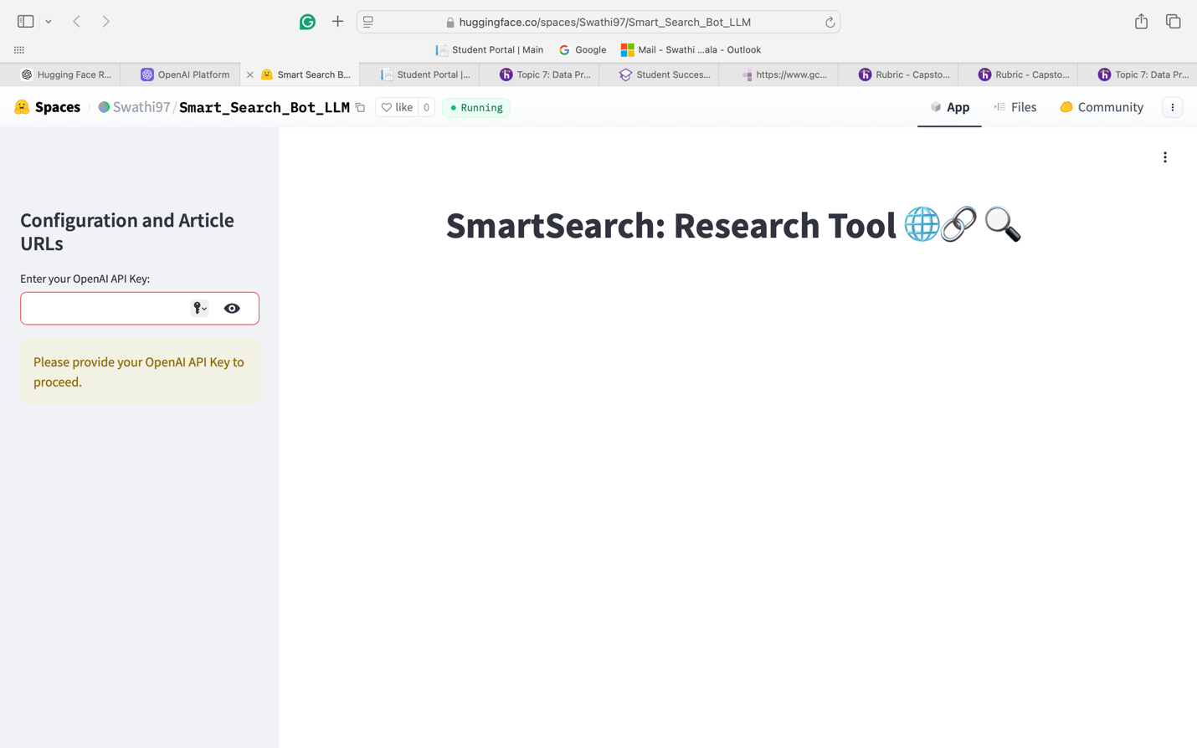

The tool validates the key. Ensure the key is correct to proceed.

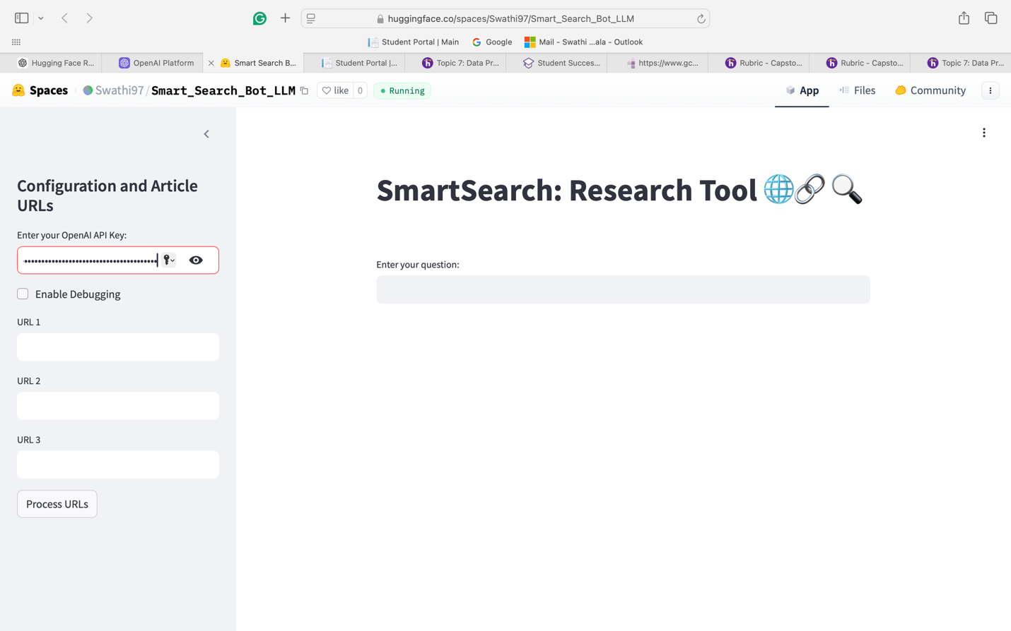

1. **Optional Debugging Mode**:
   * A checkbox labeled "Enable Debugging" allows you to activate debug logs. Use this for troubleshooting or development purposes. It is optional.

**Inputting Article URLs**

1. **Add URLs**:
   * Input up to three article URLs in the provided fields under "Configuration and Article URLs."
   * Ensure URLs are valid and publicly accessible.
2. **Process URLs**:
   * Click the "Process URLs" button to load and analyze the provided content.
   * The application will indicate processing progress.

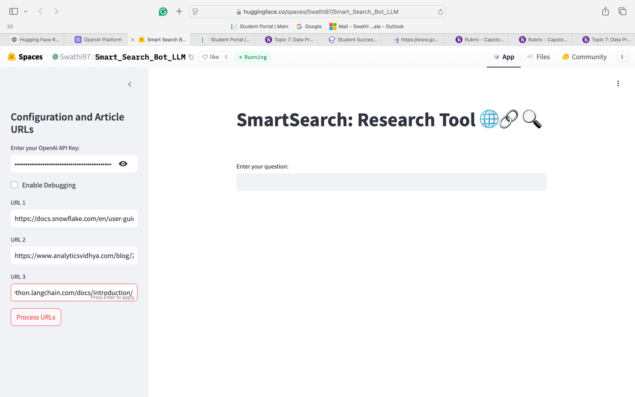

**Querying the Content**

1. **Enter Your Question**:
   * In the text field labeled "Enter your question," type your query.

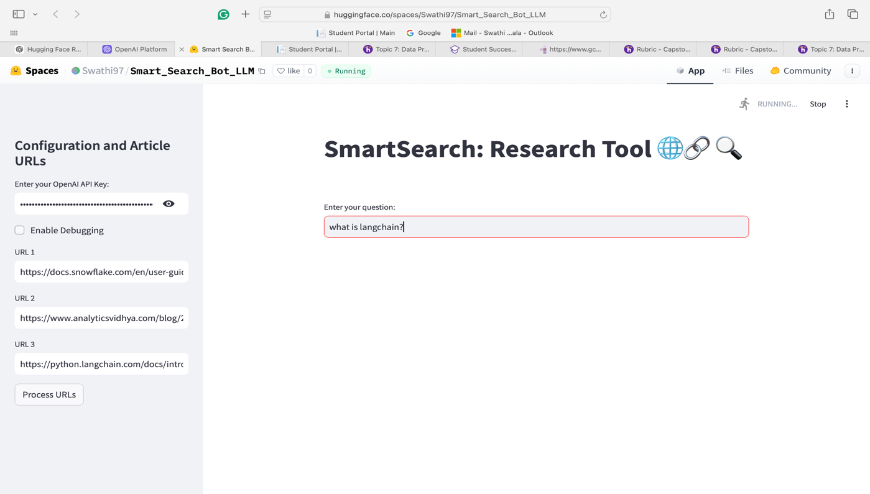

Submit the query by pressing **Enter**.

1. **Response and Sources**:
   * The tool retrieves relevant content from processed articles and displays a detailed answer.
   * Sources for the information are listed below the answer for transparency.

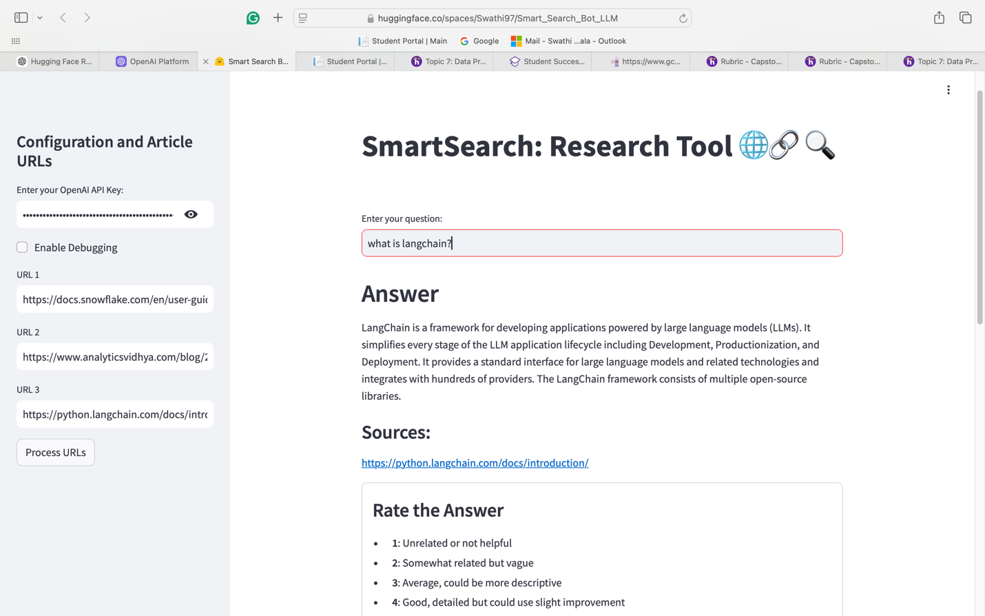

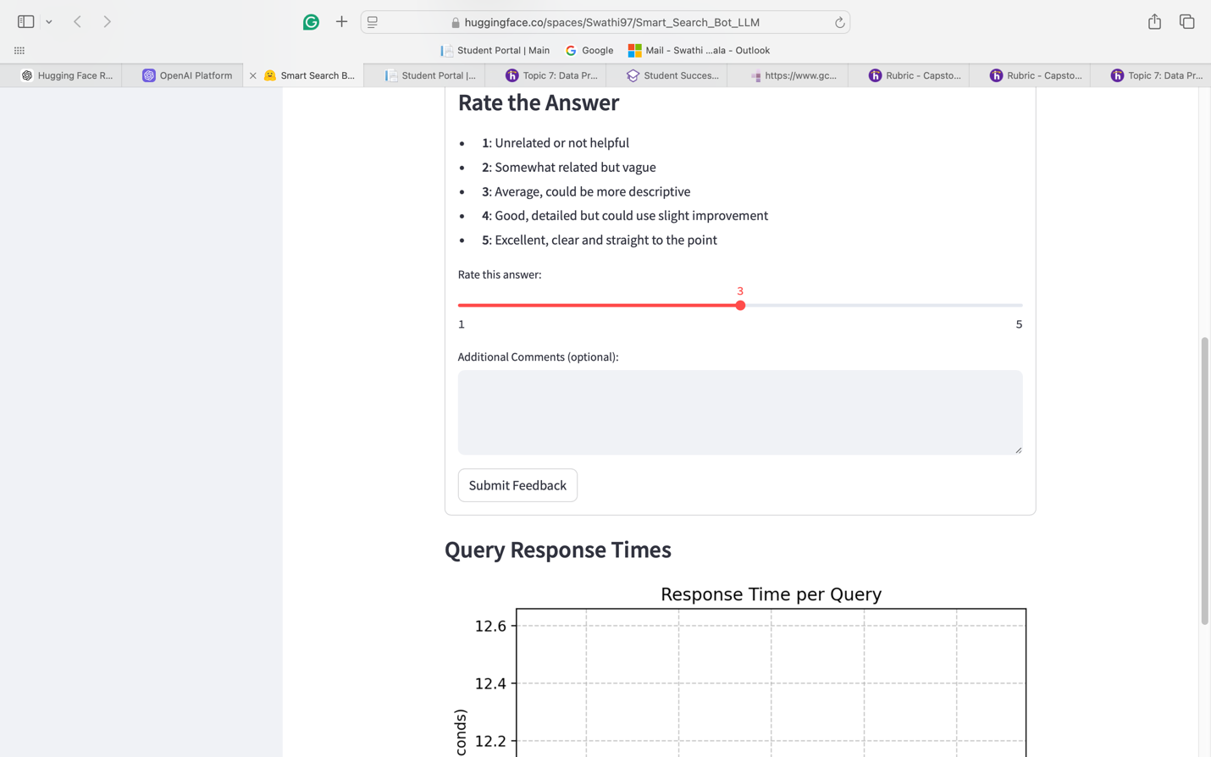

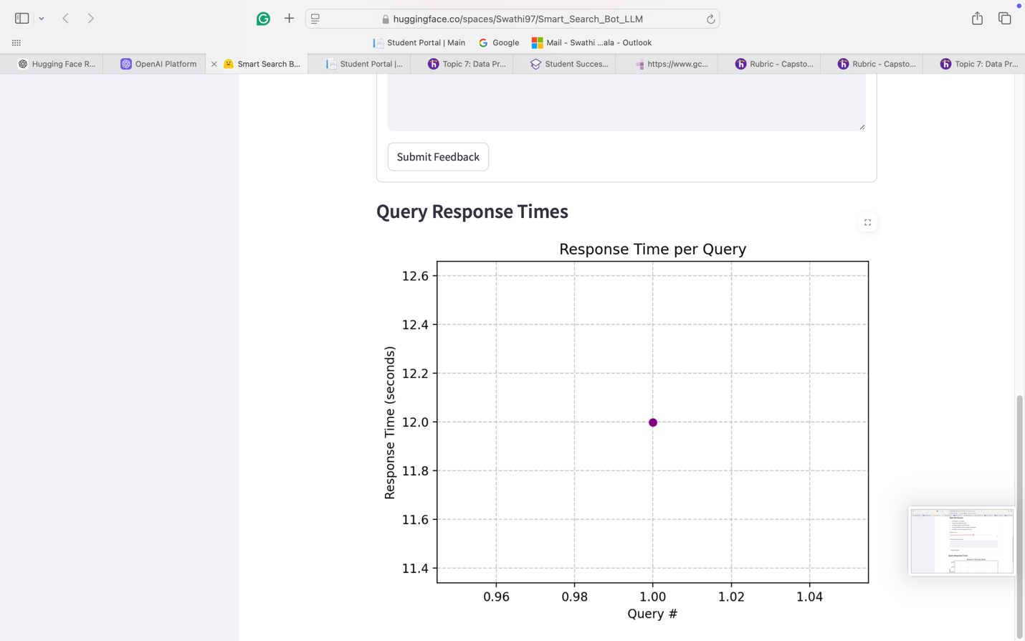

**Feedback and Ratings**

1. **Rate the Answer**:
   * Use the slider to rate the relevance and accuracy of the response.
   * Ratings range from 1 (Unrelated) to 5 (Excellent).
2. **Submit Feedback**:
   * After selecting a rating, optionally provide comments to refine the system’s accuracy.
   * Click "Submit Feedback."
3. **Refinement Based on Feedback**:
   * If the rating is below 4, the system automatically refines the response and provides an updated answer.

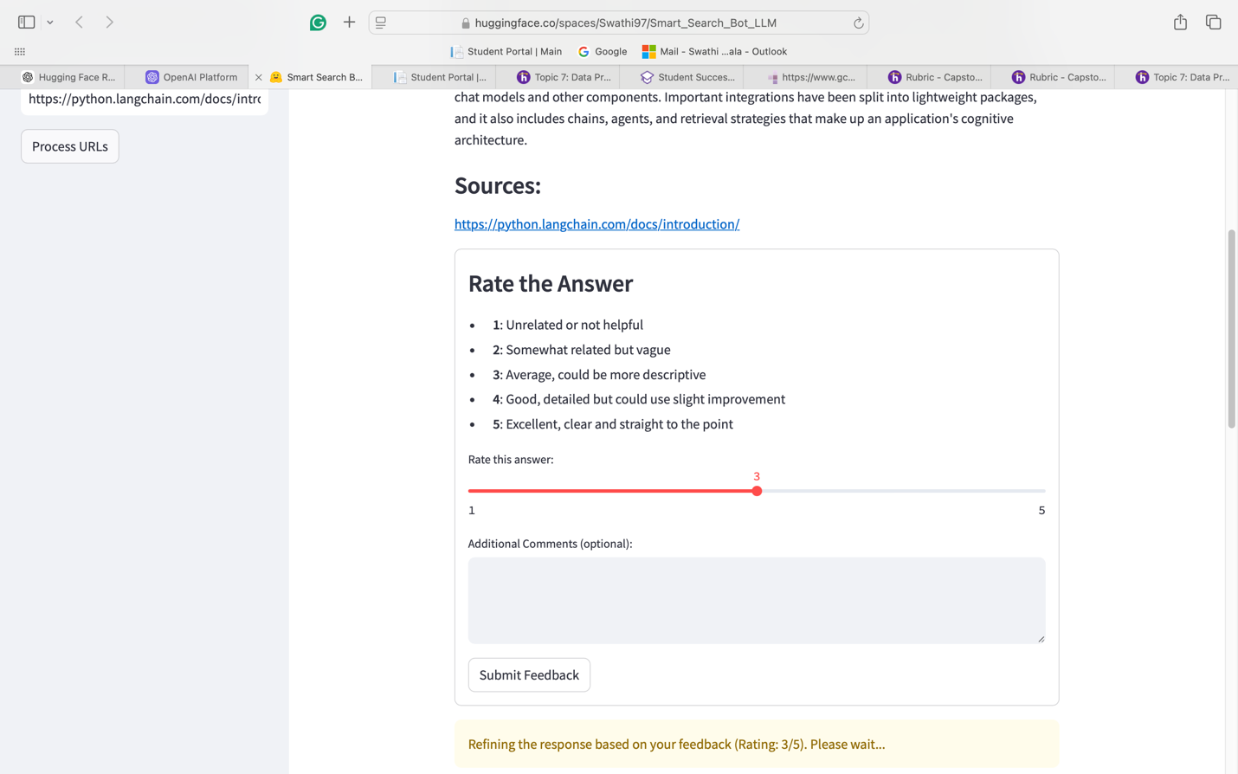

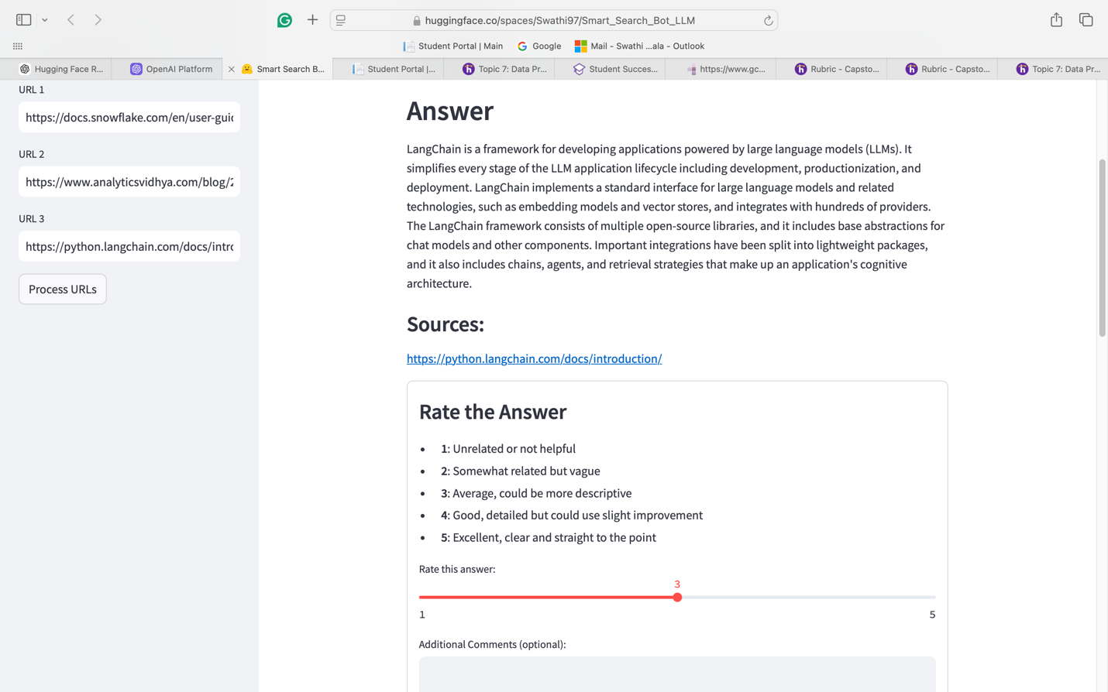

\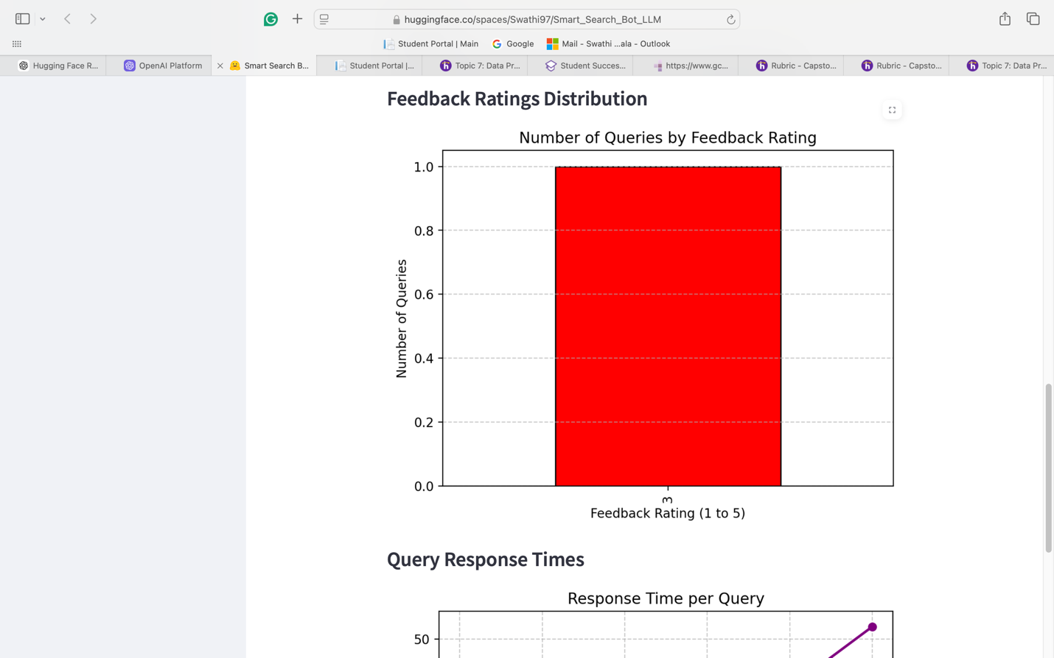

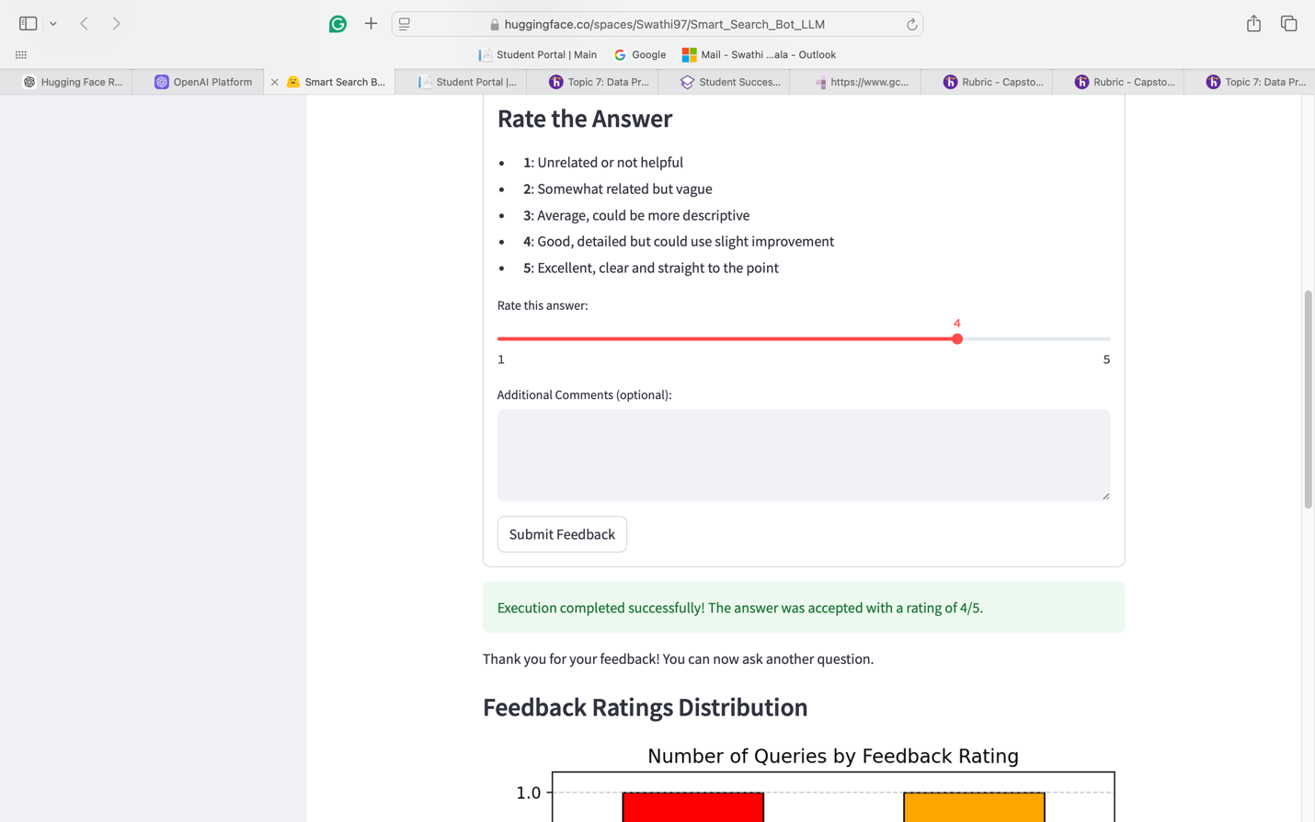

**Visualizations**

1. **Query Response Times**:
   * View a graph plotting response times for queries submitted during the session.
   * Analyze system performance based on response times.
2. **Feedback Ratings Distribution**:
   * A bar chart displays the distribution of feedback ratings.
   * Helps track user satisfaction and system improvement.

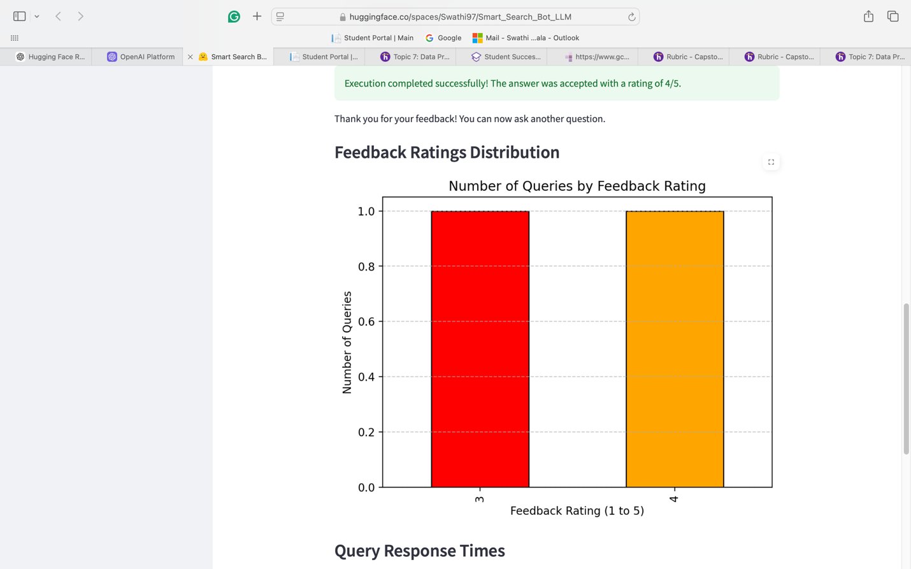

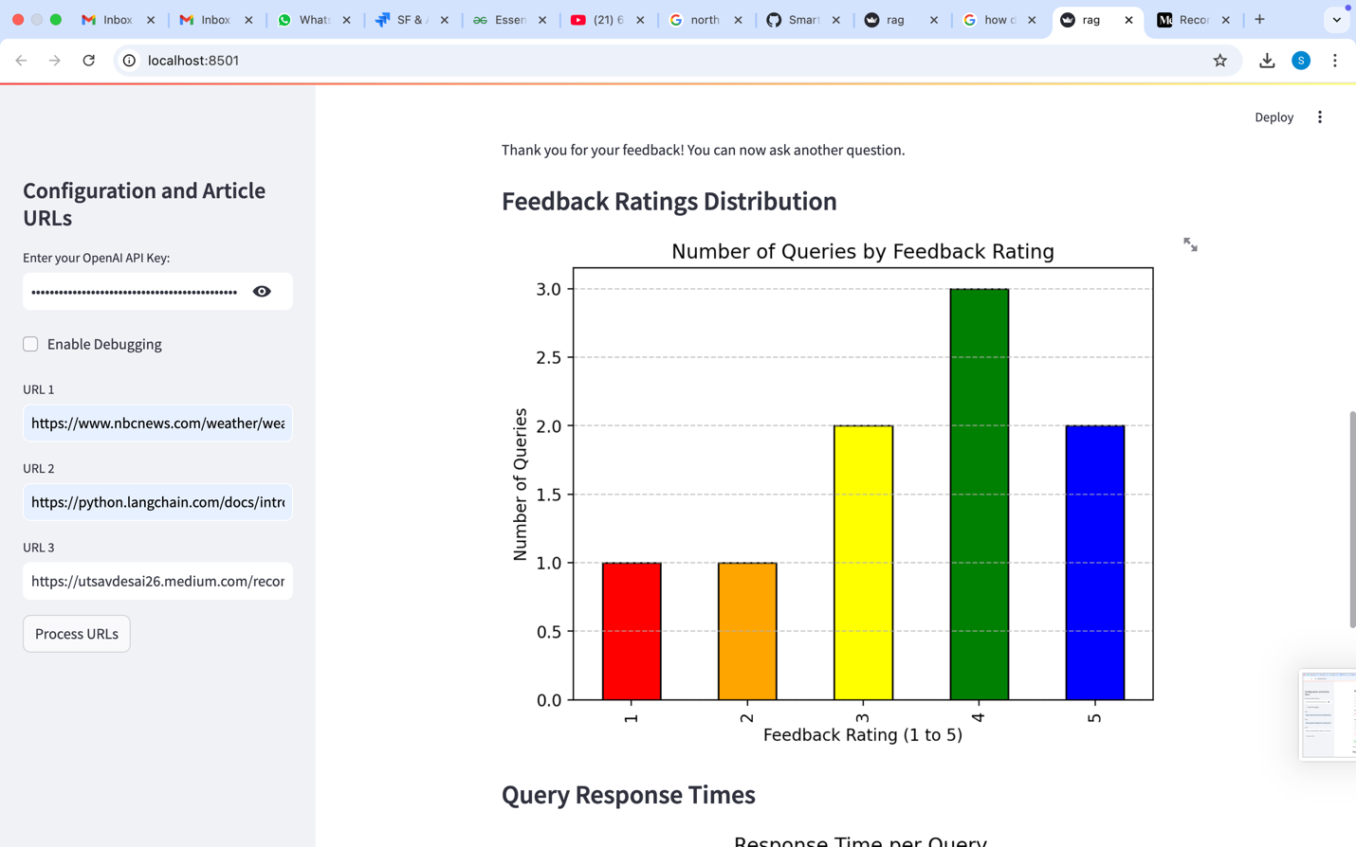

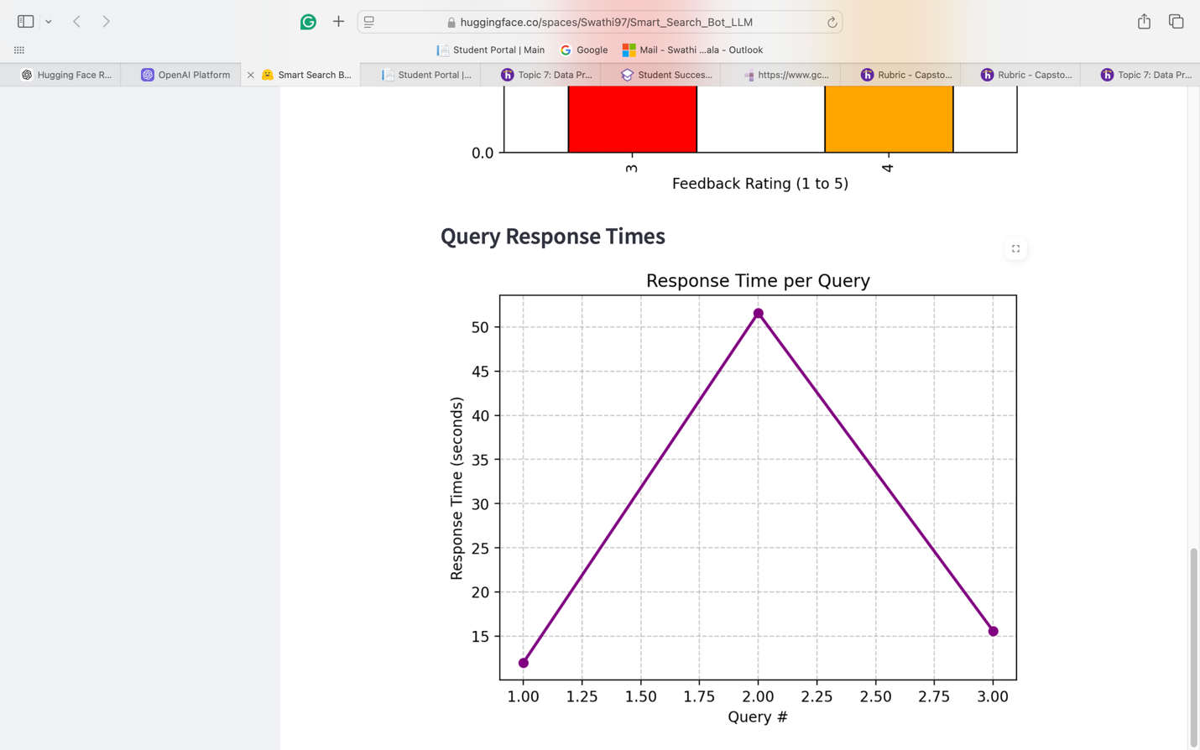

**Downloading Feedback Logs**

**New Feature: Feedback Logs Download Button**

SmartSearch now includes a feature to download feedback logs to enable detailed analysis of the queries and system performance.

**Steps to Download Feedback Logs**

1. **Submit Queries and Feedback**:
   * Use the system to input queries, receive answers, and provide ratings or comments for each response.
2. **Access the Feedback Logs Section**:
   * Navigate to the **Download Feedback Logs** section displayed after submitting feedback.
3. **Download the Logs**:
   * Click the button labeled **"Download Feedback Logs as CSV."**
   * This will generate and download a CSV file containing details of all query sessions for the current run.

**Contents of the CSV File**

The CSV file includes the following columns:

* **query**: The user's question.
* **answer**: The system's response to the query.
* **sources**: The sources referenced in the response.
* **rating**: User feedback rating (1-5).
* **comments**: Any additional user comments.
* **response_time**: Time taken (in seconds) to process and respond to the query.

**Use Case**

This feature allows users and administrators to:

* Evaluate system performance through response times.
* Analyze user satisfaction based on feedback ratings.
* Review comments for improving system capabilities

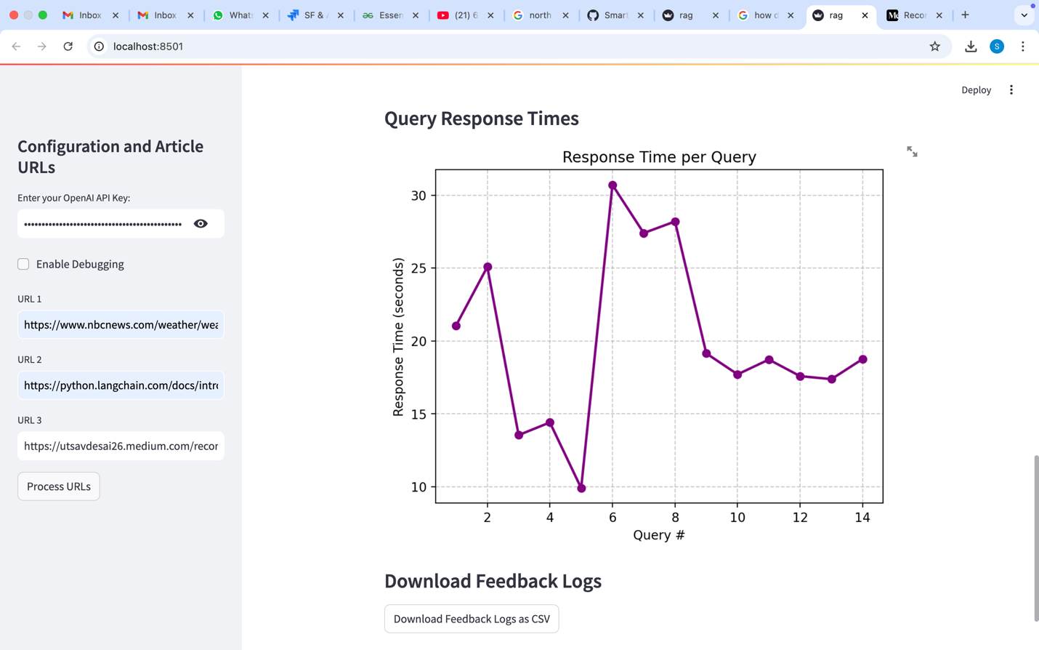

**Troubleshooting**

1. **API Key Issues**:
   * Ensure the key is active and correctly inputted.
   * Check billing setup on OpenAI if the key is not functioning.
2. **URL Processing Errors**:
   * Verify that the URLs are accessible and publicly available.
   * Avoid restricted or dynamic content URLs.

**FAQ**

1. **What happens if I input an invalid API key?**
   * The tool will prompt you to provide a valid key.
2. **Can I process more than three URLs simultaneously?**
   * Currently, the tool supports up to three URLs per session.
3. **Where are the query results stored?**
   * Embeddings are stored temporarily in a Chroma VectorStore on the server.

**Help and Contact Details**

For additional support, reach out to the administrator via the Hugging Face community page or submit an issue on the [GitHub repository](https://github.com/Swathi-Dataanalysis/Smart-Search-Bot-LLM).

**Glossary**

* **OpenAI API**: A service for accessing OpenAI's machine learning models for generating and processing natural language.
* **Chroma VectorStore**: A database used to store vector embeddings for efficient retrieval.
* **Debugging**: The process of identifying and resolving issues within a software application.

**Screenshots**

(Screenshots are now embedded throughout the relevant sections above for better contextual guidance.)